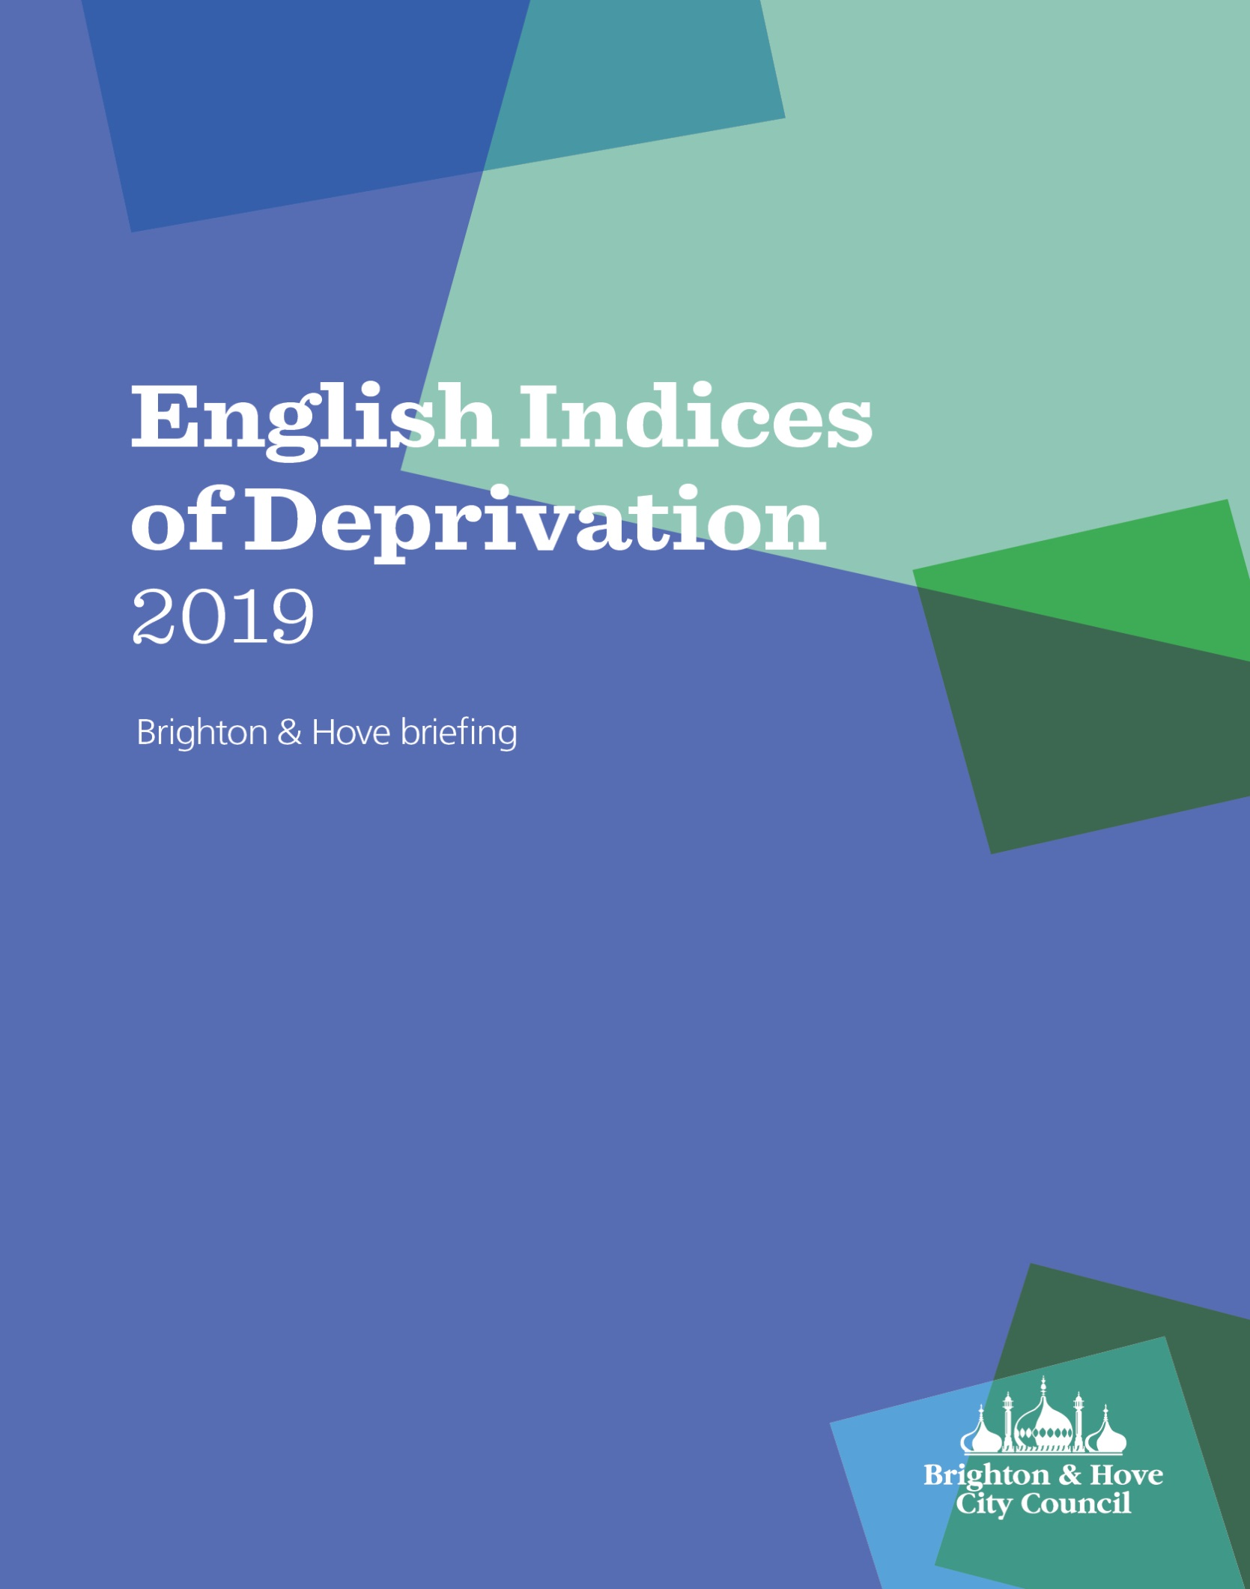Brighton & Hove Briefing:

English Indices of Deprivation 2019 (IoD 2019) and the Index of Multiple Deprivation 2019 (IMD 2019)

Page

Content

- Introduction and background................................................................... 3

2. The seven domains of deprivation……………………………………..…… 4

3. Headlines……………………………………………………………………….. 6

3.1 Index of Multiple Deprivation 2019 (IMD 2019)………..……………. 6

3.2 Overview of all ID 2019 domains and sub-domains…………………. 9

4 ID 2019 domains and sub-domains........................................................... 10

4.1 Income deprivation…………………………………………………………….. 10

4.1.1 Income domain (all people)…………………………………………… 10

4.1.2 Income deprivation affecting children (IDACI)……………………….. 11

4.1.3 Income deprivation affecting older people (IDAOPI)…………………. 12

4.2 Employment domain…………………………………………………………… 13

4.3 Education, skills and training………………………………………..…….. 14

4.4 Health Deprivation & Disability……………………………………..……… 17

.
4.5 Crime domain…………………………………………………………….……… 18

4.6 Barriers to Housing & Services domain……………………………..…….. 19

  - Living Environment………………………………………….………............. 22

5. Comparison between Indies of Deprivation 2010, 2015 and 2019…….. 25

6. Other administrative areas…………………………………………………… 27

6.1 Clinical Commissioning Groups………………………………………… 27

6.2 Local Enterprise Partnerships (LEP)…………………………………… 27

Appendix 1: Domains and indicators for the Indices of Deprivation 2019....... 29

- Introduction and background

- The purpose of the English Indices of Deprivation 2019 (IoD) is to identify small areas of England which are experiencing multiple aspects of deprivation. It replaces the Indices of Deprivation 2015 as the official measure of deprivation in England.
- The IoD 2019 provides a relative ranking of areas across England (and therefore Brighton & Hove) according to their level of deprivation.
- The IoD 2019 is based on the small area geography known as Lower Super Output Areas (LSOAs). LSOAs have between 1,000 and 3,000 people living in them with an average population of 1,500 people.
- There are 32,844 LSOAs in England and 165 in Brighton & Hove. This allows the identification of small pockets of deprivation at a geographical level lower than electoral wards.
- The IoD 2019 is based on 39 separate indicators, organised across seven distinct domains of deprivation which are combined, using appropriate weights, to calculate the Index of Multiple Deprivation (IMD) 2019. This is an overall measure of multiple deprivation experienced by people living in an area and is calculated for every LSOA in England. Each LSOA in England is ranked according to its level of deprivation relative to that of other areas. The LSOA ranked 1 is the most deprived and that ranked 32,844 is the least deprived.
- The IoD 2019 is based on broadly the same methodology as the 2010 and 2015 indices. Although it is not possible to use the indices to measure changes in the absolute level of deprivation in places over time, it is possible to explore changes in relative deprivation, or changes in the pattern of deprivation, between this and previous versions of the indices.
- The IoD 2019 is a measure of deprivation; at the opposite end of the scale it does not measure affluence. The LSOAs ranked nearest to 32,844 simply contain less deprivation than LSOAs ranked nearer to one but give no indication as to the relative affluence of an area.

Further reading about the IoD 2019 can be found on the .gov.uk official government site.
Data and maps specific to Brighton & Hove can be found on the Community Insight, part of Brighton & Hove Connected.

2. The seven domains of deprivation
The seven domains that make up the IMD 2019 are:
Income Deprivation Domain: Measures the proportion of the population experiencing deprivation relating to low income. The definition of low income used includes both those people that are out-of-work, and those that are in work but who have low earnings (and who satisfy the respective means tests). The domain estimates the actual proportion of people living in income deprivation in a given area.
Employment Deprivation Domain: Measures the proportion of the working age population in an area involuntarily excluded from the labour market. This includes people who would like to work but are unable to do so due to unemployment, sickness or disability, or caring responsibilities. The domain estimates the actual proportion of people living in employment deprivation in a given areas.

Education, Skills and Training Deprivation Domain: Measures the lack of attainment and skills in the local population. The indicators fall into two sub-domains: one relating to children and young people and one relating to adult skills.
Health Deprivation and Disability Domain: Measures the risk of premature death and the impairment of quality of life through poor physical or mental health. The domain measures morbidity, disability and premature mortality but not aspects of behaviour or environment that may be predictive of future health deprivation.
Crime Domain: The Crime Domain measures the risk of personal and material victimisation at local level.
Barriers to Housing and Services Domain: Measures the physical and financial accessibility of housing and local services. The indicators fall into two sub-domains: ‘geographical barriers’, which relate to the physical proximity of local services, and ‘wider barriers’ which includes issues relating to access to housing such as affordability and homelessness.
Living Environment Deprivation Domain. The Living Environment Deprivation Domain measures the quality of the local environment. The indicators fall into two sub-domains. The ‘indoors’ living environment measures the quality of housing; while the ‘outdoors’ living environment contains measures of air quality and road traffic accidents.
There are also two supplementary indices that are sub-sets of the Income Deprivation Domain.
Income Deprivation Affecting Children Index (IDACI): Measures the percentage of all children aged 0 to 15 years living in income deprived families.
Income Deprivation Affecting Older People Index (IDAOPI): Measures the percentage of all those aged 60 years or over who experience income deprivation.
Each of these domains is based on a basket of indicators. As far as is possible, each indicator is based on data from the most recent time point available. In practice for most indicators this will be earlier than 2019 and includes some data from the 2011 UK Population Census.
The separate indicators that make up each domain, and the weighting given to each domain, in the final IMD 2019 can be found in Appendix 1.
New for IoD 2019, the underlining data for 22 of the 39 indicators that make up the seven domains of deprivation are published at the LSOA level (see Table 1).

Table 1: Underlining indicators published as part of the English Indices of Deprivation 2019
Domain | Indicator
Income deprivation domain | Income Deprivation Domain numerator
Income deprivation domain | Income Deprivation Affecting Children Index Numerator
Income deprivation domain | Income Deprivation Affecting Older People Index Numerator
Employment deprivation domain | Employment Deprivation Domain numerator
Education, Skills and Training Deprivation Domain | Staying on in education post 16
Education, Skills and Training Deprivation Domain | Entry to higher education
Education, Skills and Training Deprivation Domain | Adult skills and English language proficiency indicators - combined
Health Deprivation and Disability Domain | Years of potential life lost
Health Deprivation and Disability Domain | Comparative illness and disability ratio
Health Deprivation and Disability Domain | Acute morbidity
Health Deprivation and Disability Domain | Mood and anxiety disorders
Barriers to Housing and Services Domain | Road distance to a post office
Barriers to Housing and Services Domain | Road distance to a primary school
Barriers to Housing and Services Domain | Road distance to general store or supermarket
Barriers to Housing and Services Domain | Road distance to a GP surgery
Barriers to Housing and Services Domain | Household overcrowding
Barriers to Housing and Services Domain | Homelessness
Barriers to Housing and Services Domain | Housing affordability
Living Environment Deprivation Domain | Housing in poor condition
Living Environment Deprivation Domain | Houses without central heating
Living Environment Deprivation Domain | Air quality indicator
Living Environment Deprivation Domain | Road traffic accidents indicator

3. Headlines

The IoD 2019 ranks all LSOAs in England for all seven main domains, six sub-domains, the IMD and the supplementary indices IDACI and IDAOPI. Similar to IoD 2015, IoD 2019 also ranks 317 local authorities districts in England by IMD, all main domains, subdomains and supplementary indices.

3.1 Index of Multiple Deprivation 2019 (IMD 2019)

Out of 317 authorities, Brighton & Hove is ranked 131 most deprived authority in England (using the most commonly used summary measure, average score). This means we are just in the third quintile (41%) of most deprived authorities in England.
Of the 312 authorities where comparisons can be made between IMD 2019 and IMD 2015, Brighton and Hove’s improved ranking (29 places) is the eighth biggest improvement among all authorities and the joint best (with Exeter) outside of London (Table 2).
Table 2: The ten most improved local authorities ranked according to the IMD 2019 and IMD 2015. Local authorities are ranked by average score (a lower rank indicates a comparatively higher level of deprivation).
 | IMD Rank |  | Improvement
 | 2019 | 2015 | Improvement
 | Out of 317 authorities | Out of 326 authorities | Improvement
Westminster | 137 | 57 | + 80
Camden | 138 | 84 | + 54
Waltham Forest | 82 | 35 | + 47
Tower Hamlets | 50 | 10 | + 40
Lambeth | 81 | 44 | + 37
Redbridge | 173 | 138 | + 35
Southwark | 72 | 40 | + 32
Brighton and Hove | 131 | 102 | + 29
Exeter | 189 | 160 | + 29
Islington | 53 | 24 | + 29

Looking at the IMD at LSOA level in Brighton & Hove, there are 15 neighbourhoods (9%) in the 10% most deprived in England, two fewer than there were 2015 and four fewer than in 2010 (Table 3 below). All 15 neighbourhoods were in the 10% most deprived in 2015 and 14 were in the 10% most deprived in 2010. At the opposite end of the scale we have ten neighbourhoods in the least deprived 10%, up from only one in 2010.
Table 4: National ranking for the five most and least deprived LSOAs in Brighton & Hove
Table 3: Number of Brighton & Hove LSOA in each national decile of deprivation

Decile | IMD 2019 | IMD 2015 | IMD 2010 | Difference 2010 / 2019
1 - most deprived | 15 | 17 | 19 | -4
2 | 14 | 17 | 18 | -4
3 | 17 | 21 | 32 | -15
4 | 12 | 21 | 21 | -9
5 | 15 | 16 | 20 | -5
6 | 25 | 20 | 22 | +3
7 | 21 | 20 | 15 | +6
8 | 22 | 21 | 10 | +12
9 | 14 | 7 | 6 | +8
10 – least deprived | 10 | 5 | 1 | +9

 | I0D 2019 | IoD 2015
Most deprived | 291 | 331
Most deprived | 434 | 337
Most deprived | 618 | 339
Most deprived | 640 | 373
Most deprived | 656 | 458
Least deprived | 31,105 | 30,002
Least deprived | 31,398 | 30,006
Least deprived | 31,516 | 30,078
Least deprived | 31,795 | 31,602
Least deprived | 31,899 | 31,646

This pattern of the most deprived ranked neighbourhoods remaining the most deprived across the three releases of the IoD is not unique to Brighton & Hove and is seen in other authorities and nationally.
Overall, compared to 2010 we have 37 fewer neighbourhoods in the 50% most deprived and 37 more neighbourhoods in the 50% least deprived areas across England.
Looking at the ranking of the most and least deprived LSOAs in Brighton & Hove (Table 4), reveals that the city has a wide range of differing levels of deprivation with some neighbourhoods in the 1% most deprived in England as well as neighbourhoods in the 1% least deprived. While having a broad range of levels of deprivation within the same authority is not unique to Brighton & Hove, having such a wide range can be considered rare.
The city’s most deprived LSOA is rank nearer to one that it was in 2015 and the least deprived neighbourhood is ranked nearer to 32,844 than it was in 2015 (Table 4). This does not mean that the gap between our most and least deprived areas are widening, only that the rankings are widening. However, the increasing numbers of LSOAs in the less deprived deciles suggest that the gap between the most deprived areas of the city and the least deprived areas of the city is likely to be narrowing.

Figure 1: Brighton & Hove’s most
deprived neighbourhood, IMD 2019

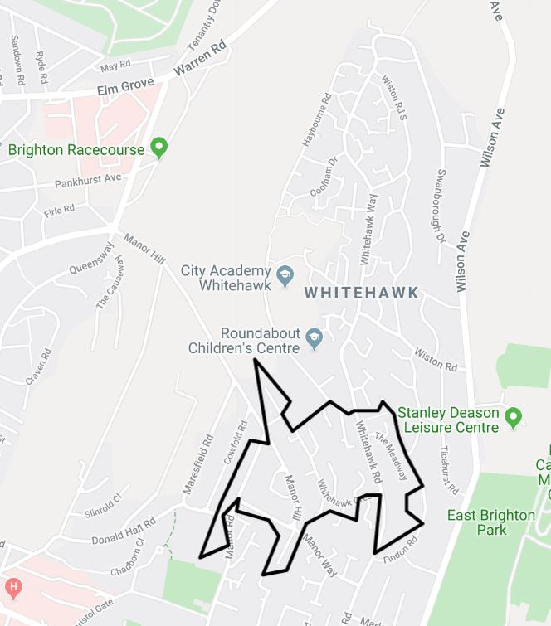
Brighton & Hove’s most deprived area (ranked 294 out of 32,844 in England) is in Whitehawk, in the area between Whitehawk Road and Manor Hill (Figure 1).
Along with parts of Queens Park ward, the Whitehawk estate is the city’s most deprived area with six LSOAs that cover the estate among the 7% most deprived LSOAs in England.
In 2015, Brighton & Hove’s most deprived area was the neighbourhood to the very north of the Whitehawk estate.

Map 1, shows that deprivation is distributed across the whole of the city but is more concentrated in some areas. The highest concentration of deprivation is in the Whitehawk, Moulsecoomb and Hollingbury areas of the city but also found around Grand Parade, St. James’s Street and Edward Street. To the west of the city, deprivation is more isolated and includes neighbourhoods around Downlands Drive, Portslade Academy, Portslade Village, the Knoll estate and Ingram estate.
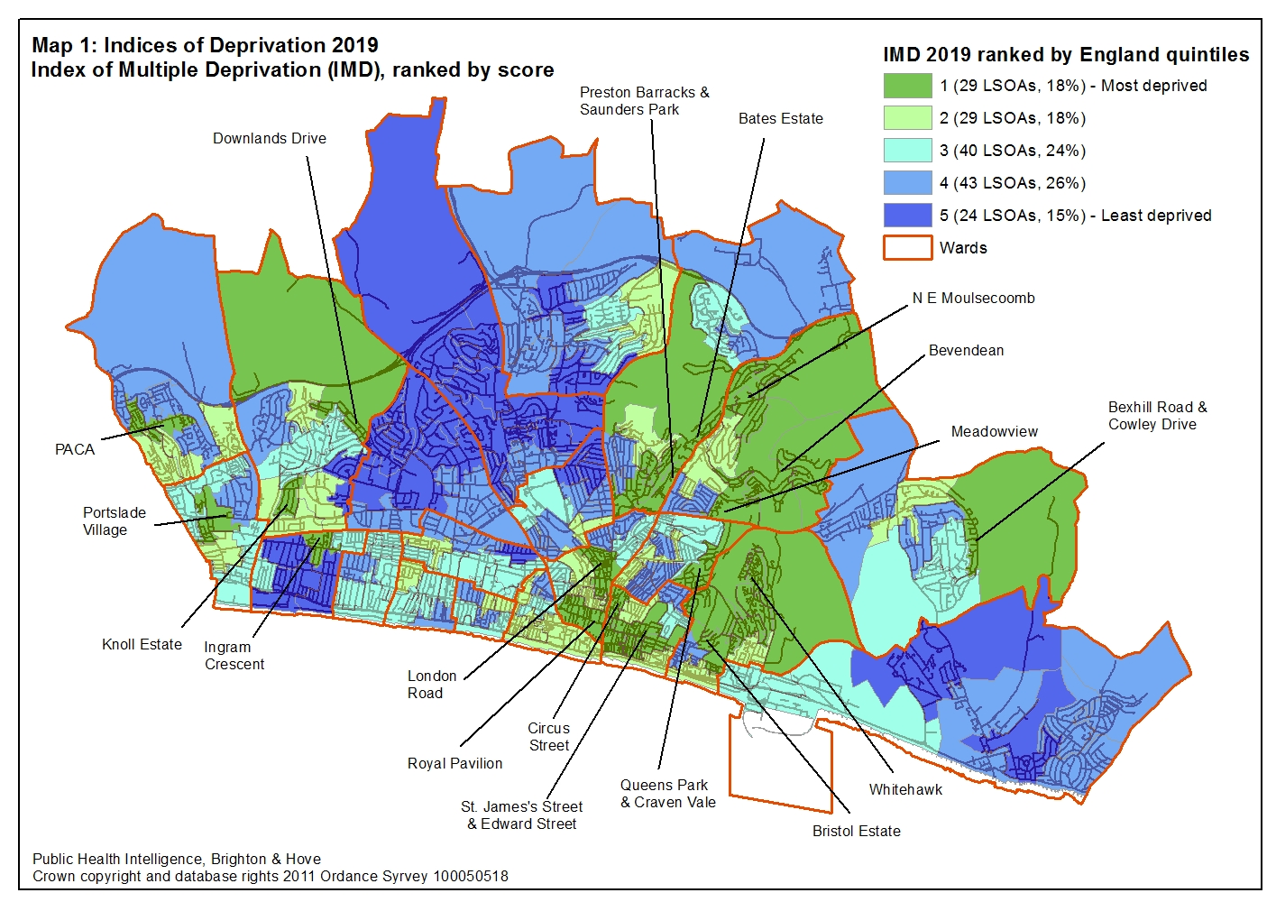
3.2 Overview of all Indices of Deprivation 2019 domains and sub-domains
Table 5 shows the number of Brighton & Hove LSOAs in each English quintile (20%) of deprivation. If deprivation in Brighton & Hove was similar to that found in the whole of England 33 or 20% of the city’s LSOAs would be in each quintile. Areas shaded in purple show quintiles where there is a higher than expected number of LSOAs and areas shaded green show quintiles where there is a lower number of LSOAs than would be expected. Where there is no shading the number of LSOAs is near to what would be expected (within plus or minus two percentage points).
For the 2019 IMD, Brighton & Hove has near the expected number of LSOAs in the first and second quintiles, more than the expected number in the third and fourth quintiles and less than the expected number of LSOAs in the fifth (least deprived) quintile.
Table 5: All Indices of Deprivation 2019 domains and sub-domains with the number and percentage of LSOAs in each English quintile (20%) of deprivation
 | 1st quintile - most deprived |  | 2nd quintile |  | 3rd quintile |  | 4th quintile |  | 5th quintile - least deprived
Index of Multiple Deprivation (IMD) | 29 | 18% | 29 | 18% | 40 | 24% | 43 | 26% | 24 | 15%
Income | 27 | 16% | 33 | 20% | 46 | 28% | 43 | 26% | 16 | 10%
Income Deprivation Affecting Children Index (IDACI) | 28 | 17% | 29 | 18% | 44 | 27% | 39 | 24% | 25 | 15%
Income Deprivation Affecting Older People (IDAOPI) | 42 | 25% | 58 | 35% | 34 | 21% | 22 | 13% | 9 | 5%
Employment | 27 | 16% | 32 | 19% | 40 | 24% | 43 | 26% | 23 | 14%
Education, Skills and Training | 28 | 17% | 23 | 14% | 25 | 15% | 40 | 24% | 49 | 30%
Children and Young People sub-domain | 37 | 22% | 28 | 17% | 39 | 24% | 35 | 21% | 26 | 16%
Adult Skills sub-domain | 21 | 13% | 22 | 13% | 13 | 8% | 21 | 13% | 88 | 53%
Health Deprivation and Disability | 35 | 21% | 33 | 20% | 33 | 20% | 45 | 27% | 19 | 12%
Barriers to Housing and Services | 17 | 10% | 67 | 41% | 49 | 30% | 28 | 17% | 4 | 2%
Geographical Barriers sub-domain | 5 | 3% | 13 | 8% | 32 | 19% | 38 | 23% | 77 | 47%
Wider Barriers sub-domain | 97 | 59% | 45 | 27% | 19 | 12% | 4 | 2% | 0 | 0%
Crime | 19 | 12% | 25 | 15% | 42 | 25% | 63 | 38% | 16 | 10%
Living Environment | 41 | 25% | 38 | 23% | 35 | 21% | 36 | 22% | 15 | 9%
Indoors sub-domain | 45 | 27% | 40 | 24% | 28 | 17% | 31 | 19% | 21 | 13%
Outdoors sub-domain | 11 | 7% | 83 | 50% | 59 | 36% | 10 | 6% | 2 | 1%
Note: Purple shading indicates a quintile with a higher than expected number of LSOAs and the green shading indicates a lower than expected number of LSOAs. The dark shading indicates a quintile with twice or more (purple) or half or less (green) the expected number of LSOAs.

For the Income, Employment, Barriers to Housing and Services and Crime domains Brighton & Hove has fewer LSOAs than expected in both the most deprived first quintile and the least deprived fifth quintile.
For the Education, Skills and Training domain Brighton & Hove has less than the expected number of LSOAs in the first and second quintiles and more than the expected number in the fourth and fifth quintiles.
For the Health Deprivation and Disability domain, Brighton & Hove has near the expected number of LSOAs in the first, second and third quintiles, with more than expected in the fourth quintile and less than expected in the fifth quintile.
For the Living Environment domain Brighton & Hove has more than the expected number of LSOAs in the first and second quintiles with fewer than the expected number of LSOAs in the fifth quintile.

4 Indices of Deprivation 2019 domains and sub-domains

4.1 Income deprivation

4.1.1 Income domain (all people)
Of the 317 authorities in England, Brighton & Hove is ranked 126 most income deprived. This means we are in the second quintile (39.7%) of most deprived authorities in England. More than one in ten of all residents (12.3%, 35,700 people) are estimated to live in income deprivation. In the 2015 index, Brighton & Hove was ranked 125 most deprived with 14.0% of residents estimated to be living in income deprivation. However, there are large differences across the city: there are six LSOAs where more than a third (33%) of residents live in income deprivation and 17 LSOAs where less than one in 20 residents (5%) do so.
In total 15 LSOAs in Brighton & Hove (9%) are in the 10% most income deprived LSOAs in England and 27 LSOAs (16%) in the 20% most deprived. Of the 15 LSOAs in the 10% most deprived, six are in East Brighton ward, two each in Hangleton & Knoll, Hollingbury & Stanmer, Moulsecoomb & Bevendean and Queen’s Park wards and one in Hanover & Elm Grove ward (Map 2).
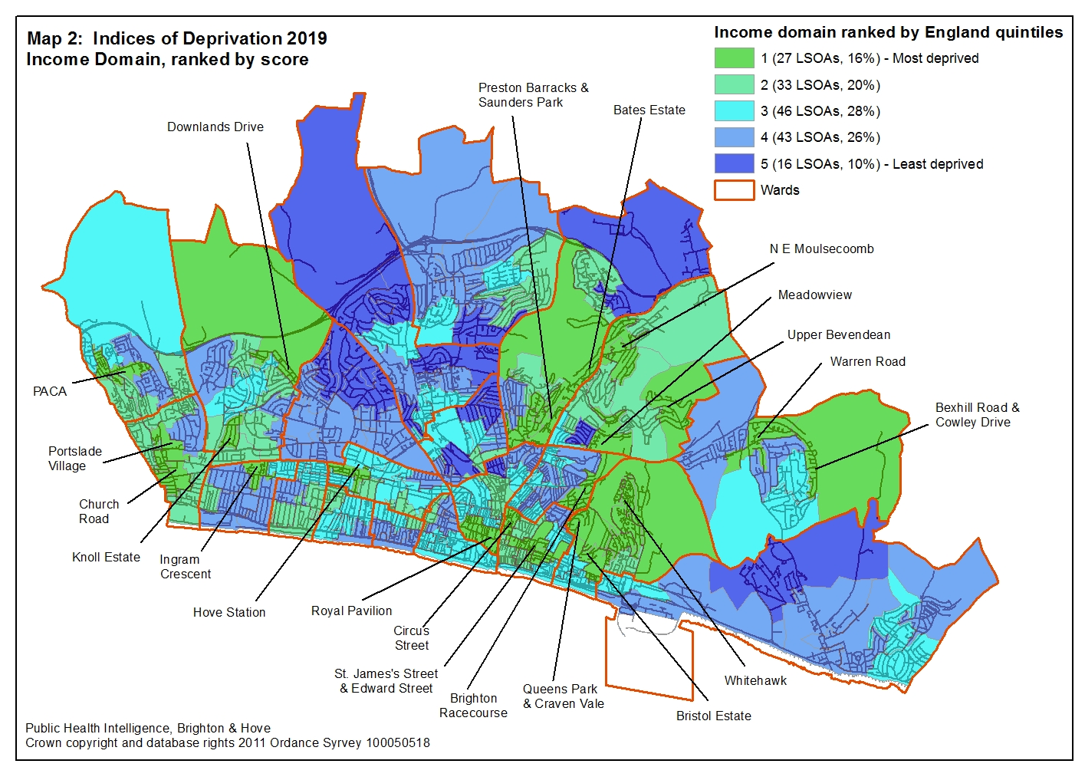

4.1.2 Income deprivation affecting children (IDACI)
Of 317 local authorities in England, Brighton & Hove is ranked 145 most income deprived for children, meaning that we are in the third quintile (46%) of most deprived authorities in England. More than one in ten children aged under 16 (15.3%, 6,900 children) live in income deprivation. In the 2015 index, Brighton & Hove was ranked 140 most deprived with 18.3% of children estimated to be living in income deprivation.
However, in one LSOA in St. Peter’s and North Laine ward (centred on Church Street), four out of five children (80%, 200 children) live in income deprivation. This is the second highest concentration of income deprived children (out of 32,844 LSOAs) in England. In another six LSOAs, two in five (40%) or more children live in income deprivation. In contrast, in one LSOA in Withdean ward less than 2% of children are income deprived.
In total, 16 LSOAs in Brighton & Hove (10%) are in the 10% most deprived in England and 28 LSOAs (17%) in the 20% most deprived. Eight of the ten LSOAs in Moulsecoomb & Bevendean ward and six out of the nine LSOAs in East Brighton ward are in the 20% most deprived in England (Map 3).
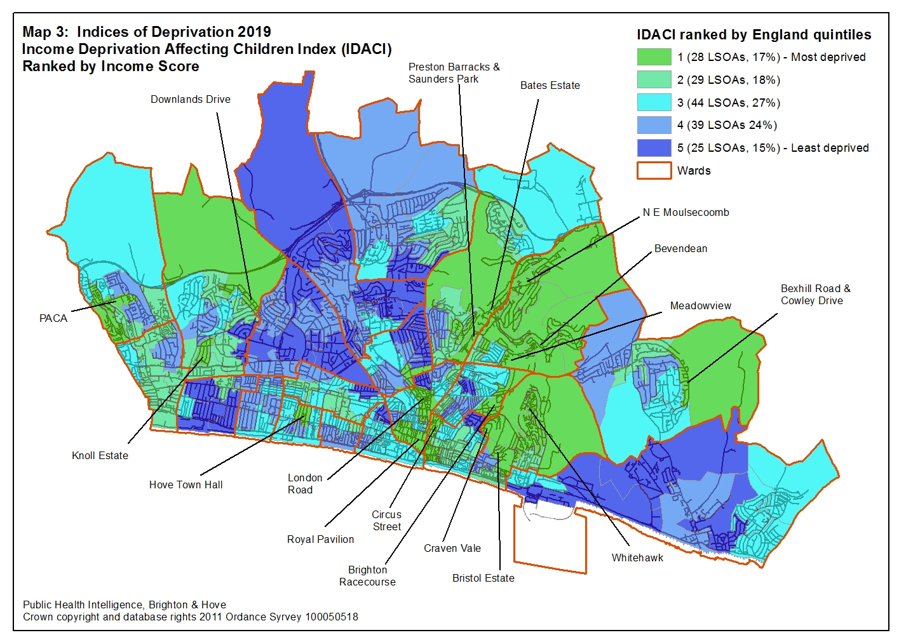

4.1.3 Income Deprivation affecting older people (IDAOPI)
Of 317 local authorities in England, Brighton & Hove is ranked 53 most income deprived for older people, meaning we are the first quintile (17%) of most deprived authorities in England. One in five residents aged 60 years or over (18.7%, 9,500 people) are living in income deprivation. However, in 22 LSOAs (13%), more than a third (33%) of older people live in income deprivation. In the 2015 index, Brighton & Hove was ranked 57 most deprived with 20.5% of residents aged 60 years or over estimated to be living in income deprivation.
In total 22 LSOAs in Brighton & Hove (13%) are in the 10% most deprived in England and 42 LSOAs (25%) in the 20% most deprived. The two most deprived LSOA are in the Tarner area of Queens Park ward and are ranked 663 and 717 out of 32,844. In both LSOAs, half of older people live in income deprivation.
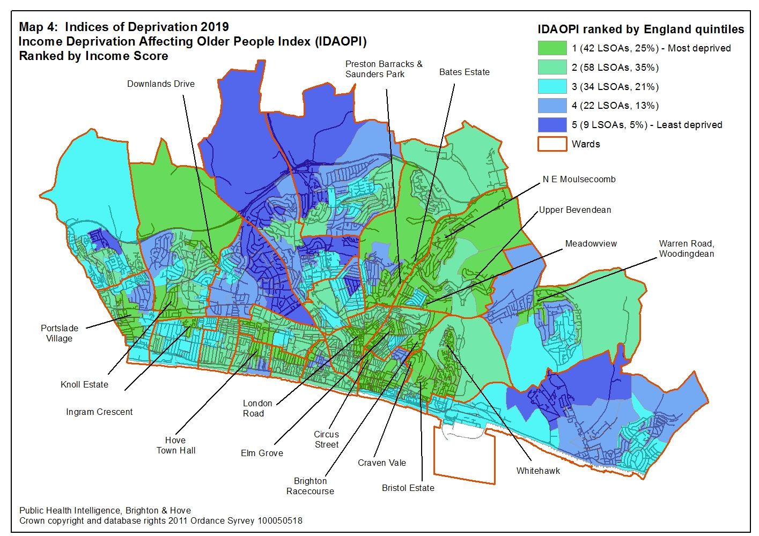

4.2 Employment domain
Of 317 authorities in England, Brighton & Hove is ranked 132 most employment deprived. This means we are just in the third quintile (42%) of most deprived authorities in England. One in ten working aged residents aged 18 to 59/64 years (9.4%, 18,300 people) are employment deprived. In the 2015 index, Brighton & Hove was ranked 142 most deprived with 11.2% of residents estimated to be living in employment deprivation.
However, in six LSOAs in the city (four in East Brighton ward and two in Queens Park ward) more than a quarter (26%) of people aged 18 to 59/64 years are employment deprived. For a further 9 LSOAs in the city one in five (20%) or more working aged people are employment deprived.
Four LSOAs (two in Queens Park ward and two in East Brighton ward) are in the 1% most deprived in England. In total 15 LSOAs in Brighton & Hove (9%) are in the 10% most deprived and 27 LSOAs (16%) in the 20% most deprived (Map 5).
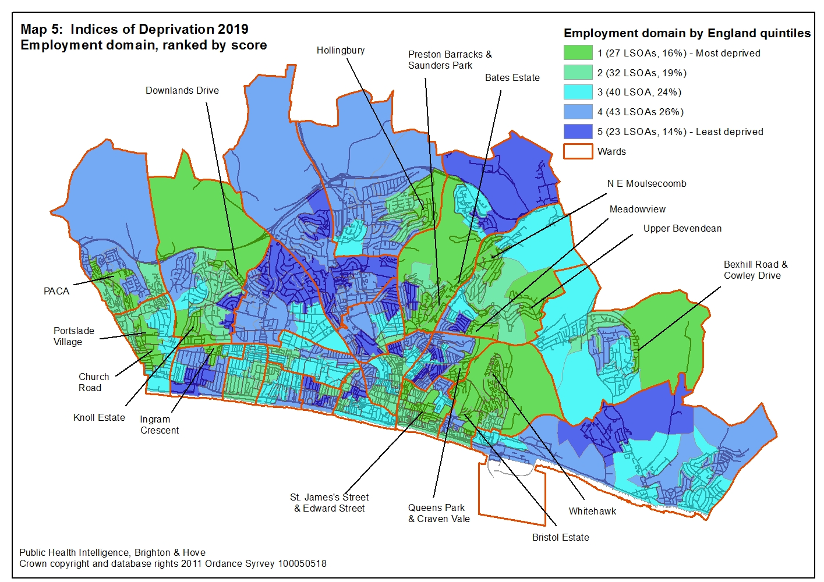

4.3 Education, skills and training domain
Of 317 authorities in England, Brighton & Hove is ranked 169 most deprived for education, skills and training - in the third quintile (53%) of most deprived authorities in England.
Five of the city’s LSOAs are in the 1% most deprived LSOAs in England, three are in East Brighton ward and two in Moulsecoomb & Bevendean ward. In total 15 LSOAs (9%) are in the 10% most deprived LSOAs in England and 28 (17%) in the 20% most deprived (Map 6).
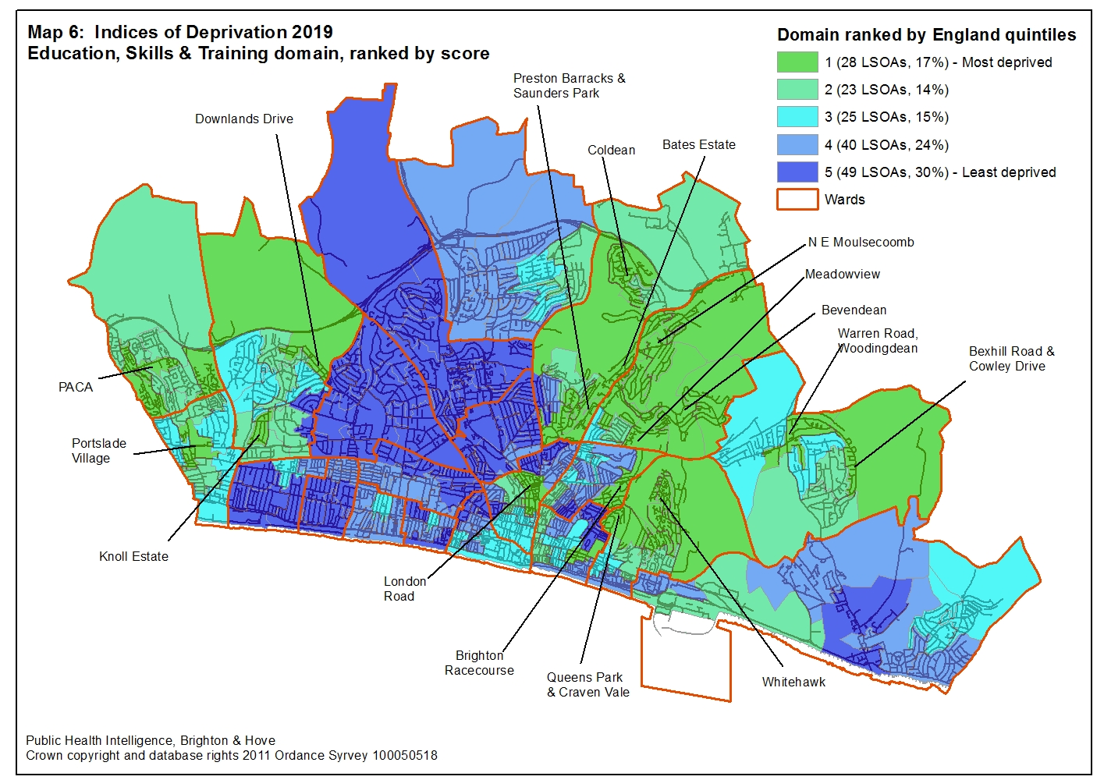

Two sub-domains, available only at the LSOA level, make up the Education, Skills and Training domain;
- Children & Young People (Map 7)
- Adult Skills (Map 8)

The two sub-domains show very different levels of deprivation (table 6 below). The Children & Young People sub-domain has nearly twice as many LSOAs in the 20% most deprived while the Adult Skills sub-domain has three times as many LSOAs in the 20% least deprived.

Table 6: Education, Skills & Training sub-domain’s by number of LSOA in each England quintile
England quintiles | Children & Young People Sub-domain | Adult Skills sub-domain
England quintiles | Number of LSOAs (% of LSOA)
1 – Most deprived | 37 (22%) | 21 (13%)
2 | 28 (17%) | 22 (13%)
3 | 39 (24%) | 13 (8%)
4 | 35 (21%) | 21 (13%)
5 – Least deprived | 26 (16%) | 88 (53%)

For the Children & Young People’s sub-domain, six LSOAs (4%) are in the 1% most deprived areas in England and 24 LSOAs (15%) are in the 10% most deprived. Eight out of ten LSOAs in Moulsecoomb & Bevendean ward are in the 10% most deprived areas in England (Map 7).
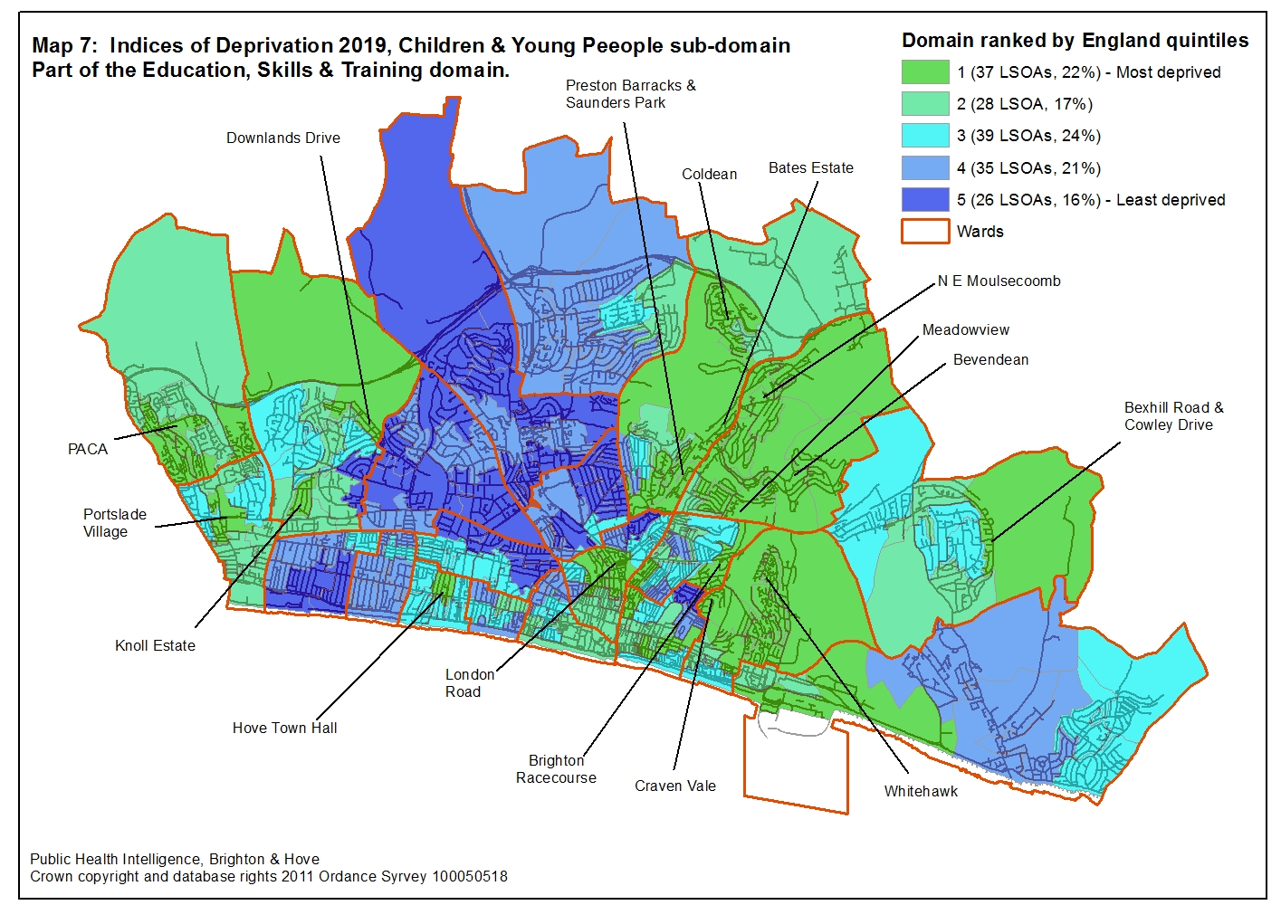

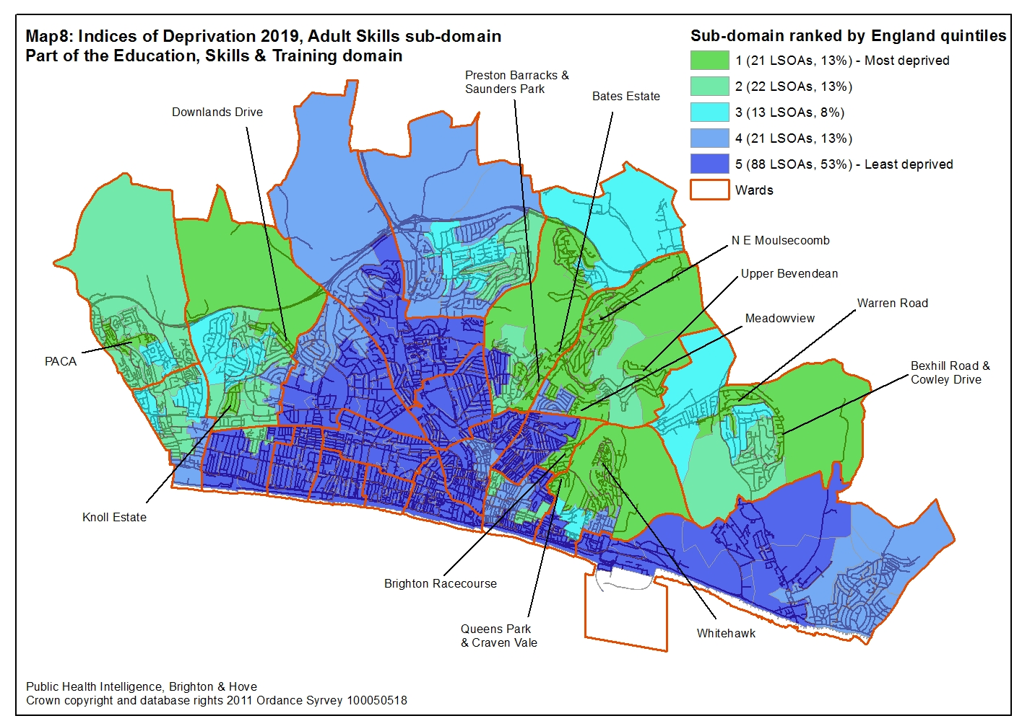

4.4 Health Deprivation & Disability domain
Of 317 authorities in England, Brighton & Hove is ranked 114 most deprived. This means we are ranked in the second quintile (36%) of most deprived authorities in England for health deprivation and disability.
Two of the city’s LSOAs (both in the Tarner area of Queens Park ward) are in the 1% most deprived LSOAs in England, 17 LSOAs (10%) are in the 10% most deprived in England and 35 LSOAs (21%) in the 20% most deprived. Of the LSOAs in the 10% most deprived in England, six are in East Brighton ward, four in Queens Park Ward, two in Hollingbury & Stanmer ward, and one each in Goldsmid, Hangleton & Knoll, Hanover & Elm Grove and Moulsecoomb & Bevendean wards (Map 9).
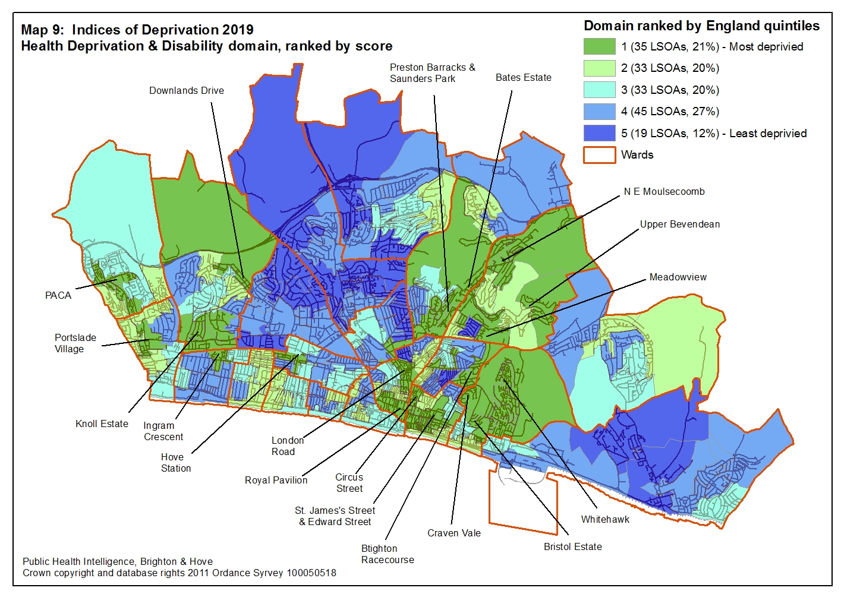

4.5 Crime domain
Of 317 authorities in England, Brighton & Hove is ranked 144 most deprived meaning that we are ranked in the third quintile (45%) of most deprived authorities in England for crime deprivation.
The seafront LSOA to the west of the Palace Pier is ranked the 130 most deprived LSOA in England for crime. In total 11 LSOAs (7%) are in the 10% most deprived in England and 19 LSOAs (12%) in the 20% most deprived.
Of the 11 LSOAs in the 10% most deprived in England, three LSOAs are in each of East Brighton, Queens Park and St. Peters & North Laine wards with the other two LSOAs found in Regency ward (Map 10).
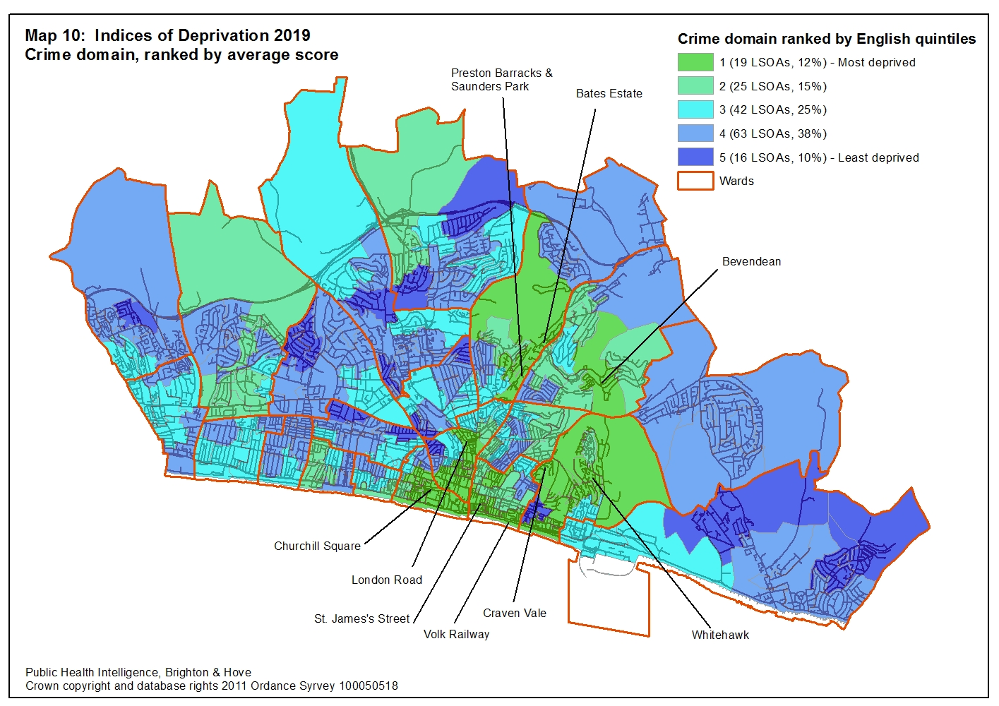

4.6 Barriers to Housing & Services domain
Of 317 local authorities in England, Brighton & Hove is ranked 124 most deprived, meaning that we are ranked just inside the second quintile (39%) of most deprived authorities in England for barriers to housing and services.
In total 6 LSOAs (4%) are in the 10% most deprived in England and 17 LSOAs (10%) in the 20% most deprived (Map 11).
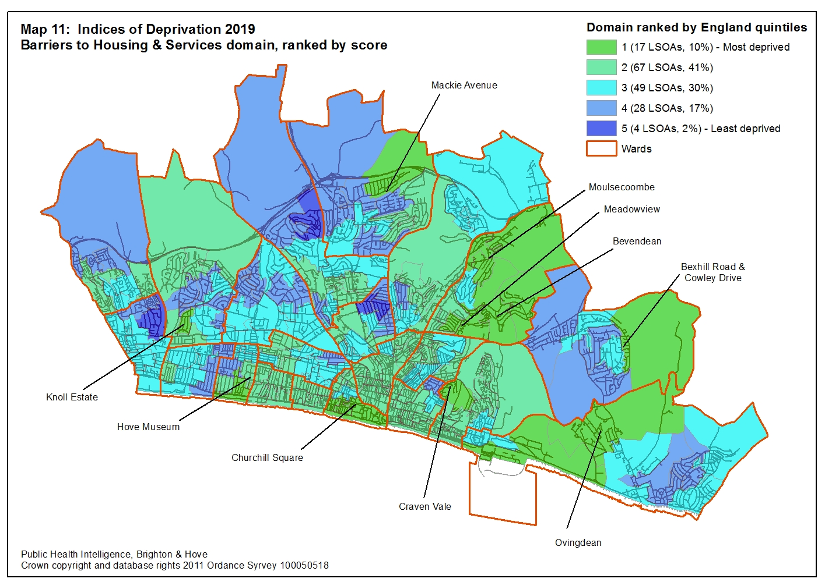

However, there are huge differences when you look at the two sub-domains (available only at the LSOA level) that make up the Barriers to Housing & Services Domain (Table 4).
While 77 (47%) of Brighton & Hove LSOAs are in the 20% least deprived in England for geographical barriers, no LSOA is in the least deprived 20% for the wider barriers (housing) sub-domain. Three out of five Brighton & Hove’s LSOAs (97, 59%) are in the most deprived 20% for the wider barriers (housing) sub-domain.

Table 4: Barriers to Housing & Services’ sub-domains by number of LSOA in each England quintile
England quintiles | Geographical Barriers | Wider barriers (housing)
England quintiles | Number of LSOAs (% of LSOA)
1 – Most deprived | 5 (3%) | 97 (59%)
2 | 13 (8%) | 45 (27%)
3 | 32 (19%) | 19 (12%)
4 | 38 (23%) | 4 (2%)
5 – Least deprived | 77 (47%) | 0 (0%)

For the wider barriers sub-domain (Map 12 below), in six Brighton & Hove wards (Brunswick & Adelaide, Central Hove, East Brighton, Moulsecoomb & Bevendean, Regency and St. Peters & North Laine) all LSOAs are in the 20% most deprived in England.
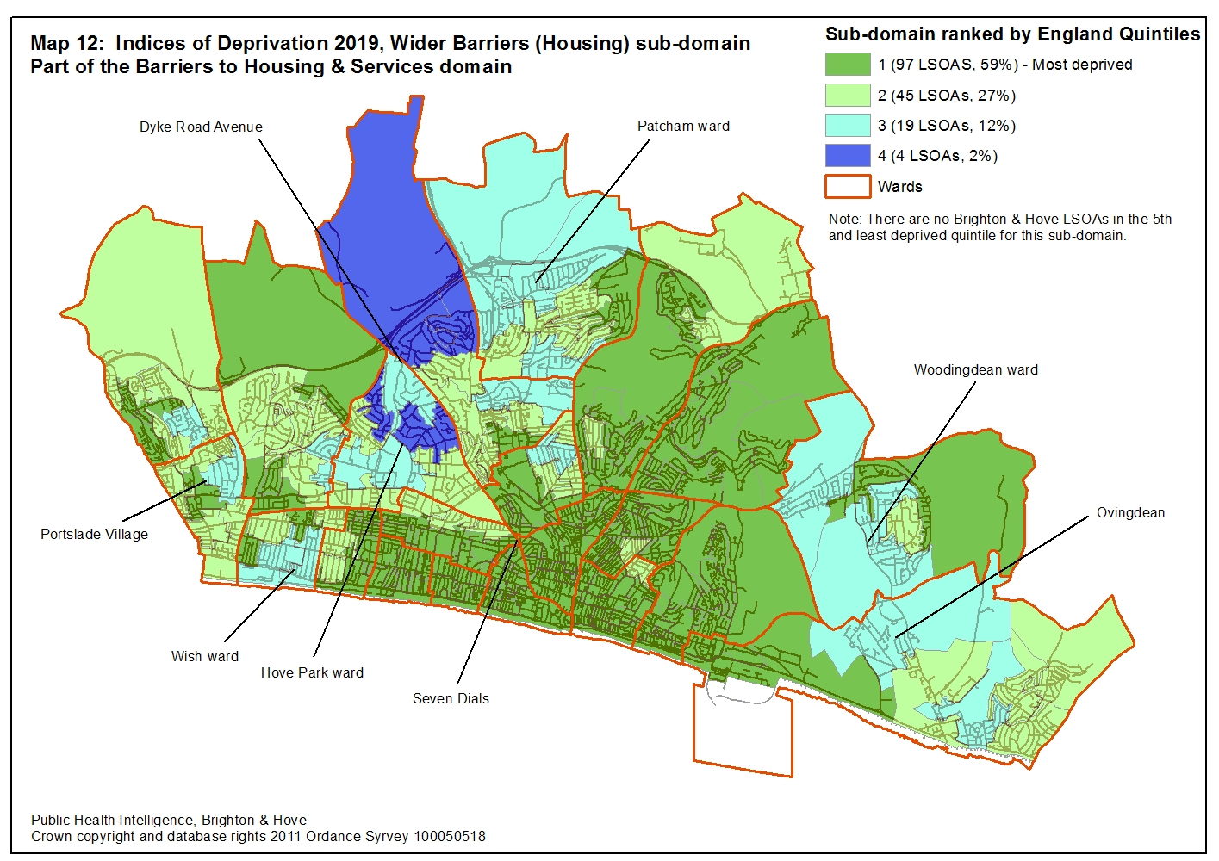

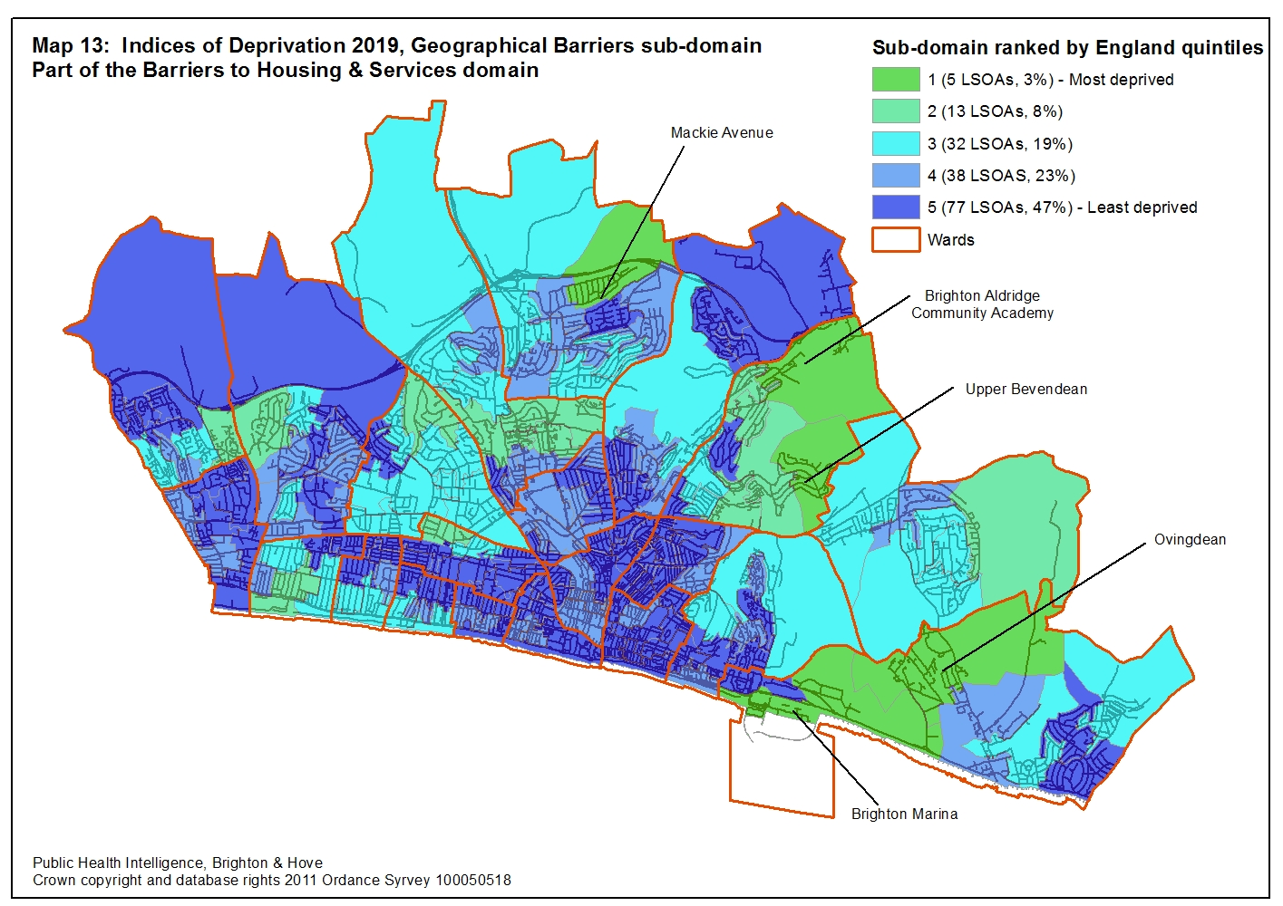

4.7 Living Environment domain
Of 317 authorities in England, Brighton & Hove is ranked 89 most deprived, meaning we are the in the second quintile (28%) of most deprived authorities in England for our living environment.
In total 14 LSOAs (8%) are in the 10% most deprived in England and 41 LSOAs (25%) in the 20% most deprive (Map 14).
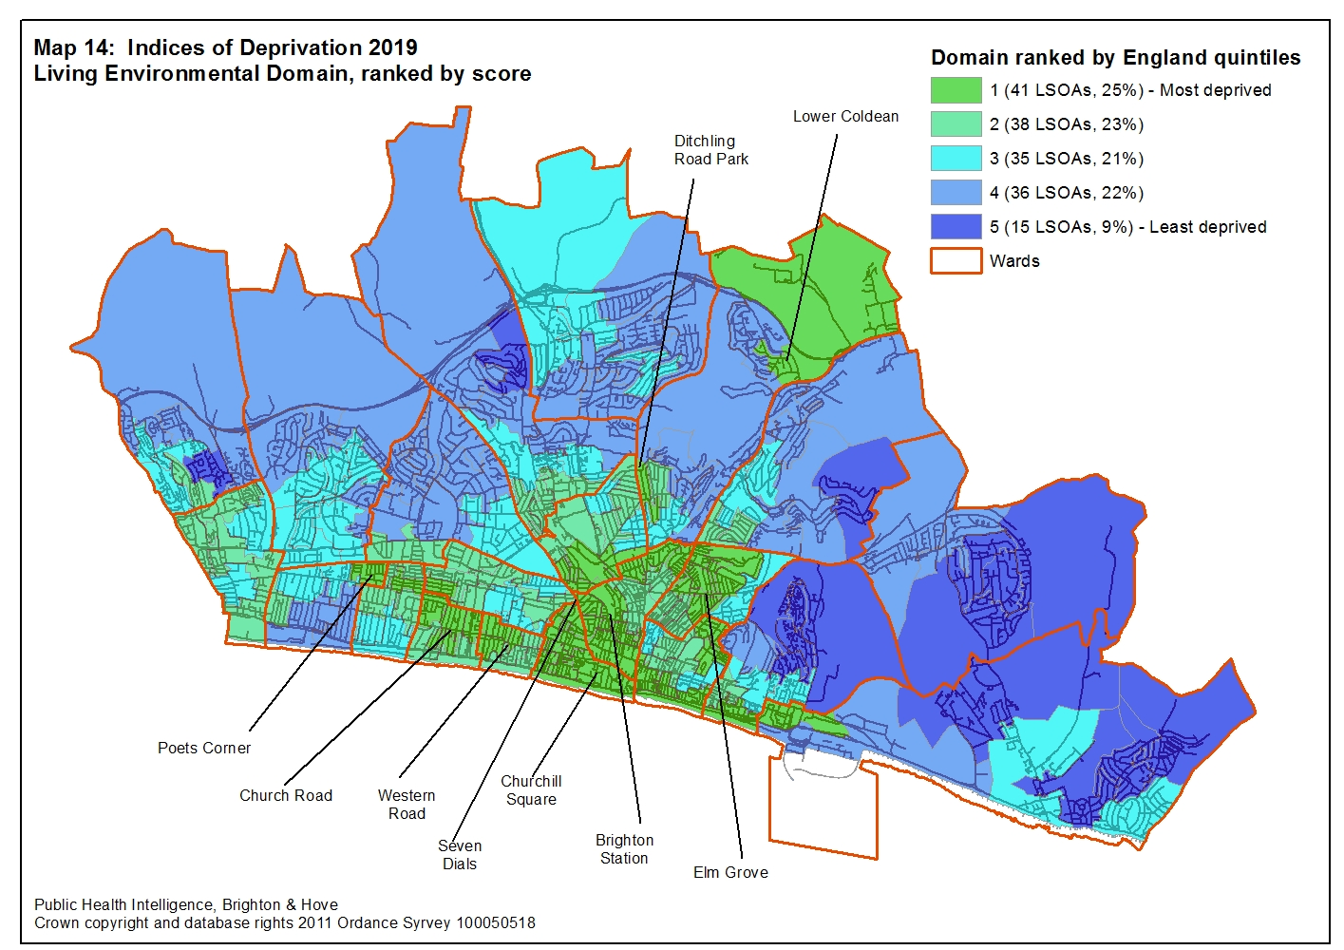

Two sub-domains, only available at the LSOA level, make up the wider Living Environment domain (Table 7).
Table 7: Living environment sub-domain’s by number of LSOA in each England quintile
Quintile | Indoor Living Environment Sub-domain | Outdoor Living Environment sub-domain
Quintile | Number of LSOAs (% of LSOA)
1 – most deprived | 45 (27%) | 11 (7%)
2 | 40 (24%) | 83 (50%)
3 | 28 (17%) | 59 (36%)
4 | 31 (19%) | 10 (6%)
5 – least deprived | 21 (13%) | 2 (1%)

For the Indoor Living Environment, 45 Brighton & Hove LSOAs (27%) are in the 20% most deprived areas in England with more than half (85 LSOAs, 52%) in the 40% most deprived. The central coastal area of the city is the most deprived for the indoor living environment. Nearly two thirds of LSOAs (64%) in the area made up of Central Hove, Brunswick & Adelaide, Regency, Queens Park, St. Peter’s & North Laine and Hanover & Elm Grove wards are in the 20% most deprived in England for this sub-domain (Map 15).
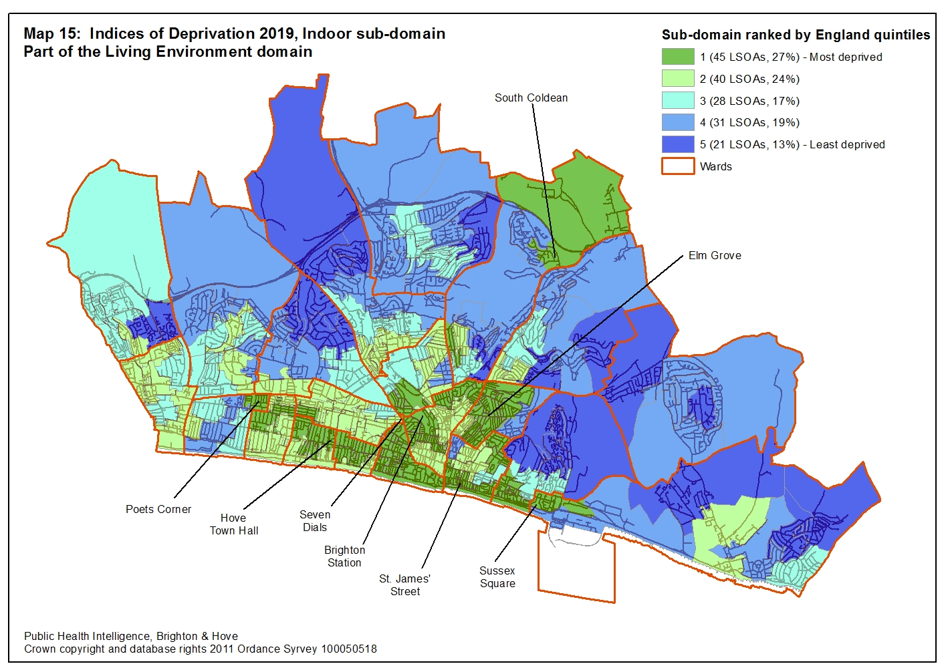

For the Outdoor Living Environment, in 2015 nearly a half of all Brighton & Hove’s LSOAs (77, 47%) were in the 20% most deprived in England with more than nine out of ten of LSOAs (152, 92%) in the 40% most deprived. In 2019, only 11 LSOAs (7%) are in the 20% most deprived and 94 LSOAs (57%) in the 40% most deprived. At the other end of the scale only two LSOAs are in the 20% least deprived and only 12 in the 40% least deprived (Map 16).
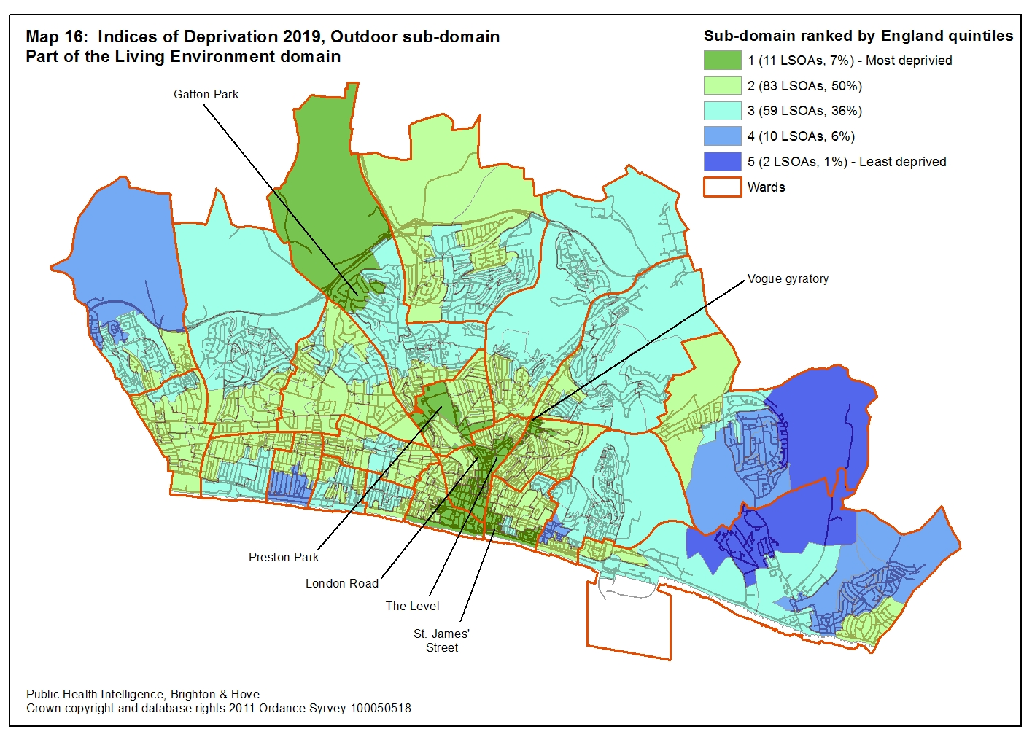

- Comparison between Indies of Deprivation 2010, 2015 and 2019
The Indices of Deprivation are a relative measure of deprivation. This means you can tell if one area is more deprived than another but not by how much. Similarly, deprivation cannot be compared between the different releases because an area’s score is affected by the scores of every other area. So it is not possible to tell whether a change in score is a real change in the deprivation level of an area or whether it is due to the scores of other areas going up or down.
However, it is possible to compare the number of LSOAs in Brighton & Hove in the first (most deprived) and fifth (least deprived) quintiles in England for the Indices of Deprivation 2010, 2015 and 2019 (Table 8). If Brighton & Hove was similarly deprived as England there would be 33 LSOAs (20%) in each quintile.
Table 8: Number of Brighton & Hove LSOAs in the first and last quintiles of the seven main domains of the 2010, 2015 and 2019 Indices of Deprivation.
 | First quintile - most deprived |  |  |  | Fifth quintile - least deprived
 | ID 2019 | ID 2015 | ID 2010 | Difference 2010 to 2019 | ID 2019 | ID 2015 | ID 2010 | Difference 2010 to 2019
Index of Multiple Deprivation | 29 | 34 | 37 | -8 | 24 | 12 | 7 | +17
Income domain | 27 | 25 | 27 | 0 | 16 | 12 | 9 | +7
Employment domain | 27 | 26 | 30 | -3 | 23 | 18 | 12 | +11
Health Deprivation and Disability domain | 35 | 35 | 72 | -37 | 19 | 7 | 0 | +19
Education, Skills & Training domain | 28 | 30 | 28 | 0 | 49 | 45 | 56 | -6
Barriers to Housing and Services domain | 17 | 29 | 46 | -29 | 4 | 1 | 0 | +4
Crime domain | 19 | 24 | 18 | +1 | 16 | 11 | 16 | 0
Living Environment domain | 41 | 69 | 73 | -32 | 15 | 3 | 8 | +7

For the IMD, continuing the trend seen since 2010, between 2015 and 2019 there are now five fewer LSOAs in the first (most deprived) quintile and 12 more in the fifth quintile. For the first time Brighton & Hove has fewer than the expected number of LSOAs in the most deprived quintile.
For the seven domains that make up the IMD, all seven have seen an increase (between 2015 and 2019) in the number of LSOAs in the least deprived (fifth) quintile. The Health and Disability and the Living Environment domains have seen the biggest increase (12 LSOAs). However, the Education, Skills and Training domain (49 LSOAs), is the only domain with more than the expected number of LSOAs in the fifth quintile. The Income (16), Crime (16), Living Environment (15) and Barriers to Health and Services (4) domains all have less than half the number of expected LSOAs in the fifth quintile.
Looking at the first quintile, only for the Health Deprivation and Disability domain (35) and the Living Environment (41) are there more than the expected number of LSOAs. However, both domains now have more than 30 fewer LSOAs in the first quintile than they did in 2010.
Map 17 shows how the ranking of LSOAs in Brighton & Hove in the 2019 IMD has changed in comparison to the 2015 IMD. The areas shaded green have become relatively more deprived while the areas shaded blue have become relatively less deprived.
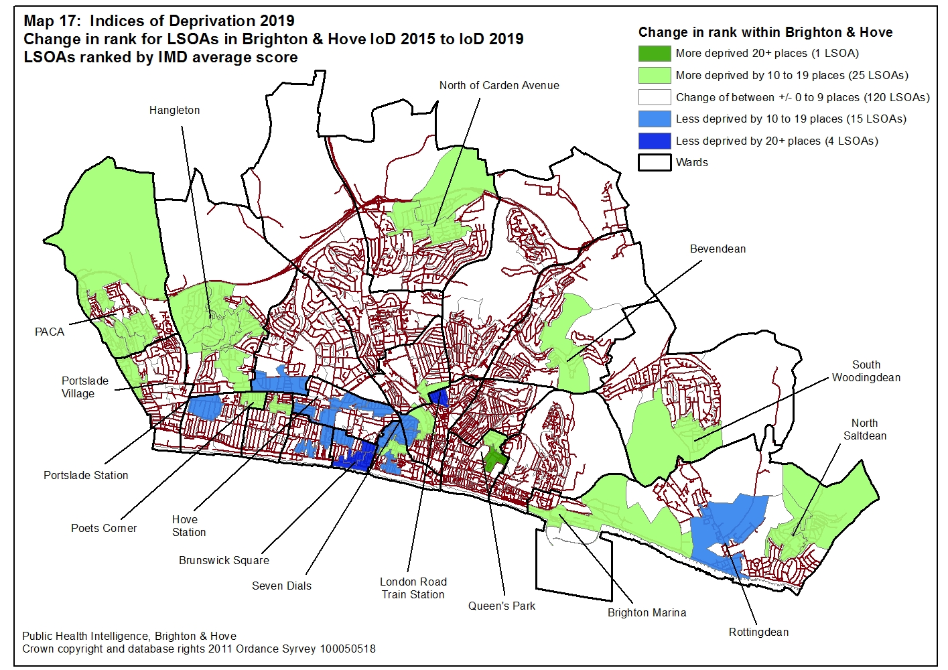

There are 165 LSOAs covering Brighton & Hove and for nearly three quarters of these LSOAs there has been relatively little change in their rankings. However, 15% or 26 LSOAs have seen their ranking fall by more than 10 places and 12% or 19 LSOAs have seen their ranking improve by more than 10 places.
Most of the neighbourhoods that have seen an improvement in their ranking are in Hove in the areas south of the Brighton and Portslade train line. The neighbourhoods that have seen the biggest improvement are around Brunswick Square and south of London Road station.
The neighbourhoods that have become relatively more deprived are more spread around the city but with some clustering near the authority boarder in both the north-west and east of the city. The neighbourhood that has seen the biggest fall in its ranking is east of Queens Park and south of Craven Vale.

- Other administrative areas
The IMD 2019, the seven main domains and IDACI and IDAOPI are available for Clinical Commissioning Groups (CCGs) and Local Enterprise Partnerships (LEPs) in England.
6.1 Clinical Commissioning Groups
NHS Brighton & Hove CCG shares the same boundary as Brighton & Hove City Council. Among the 191 CCGs in England, Brighton & Hove CCG is ranked 97 most deprived and is therefore in the third quintile of most deprived CCGs in England. Looking at the other domains, Brighton & Hove CCG is ranked in the second or third quintile for all domains apart from the Education, Skills and Training domain where we are ranked 119 and in the fourth quintile.
Table 9: Domains of the 2019 Indices of Deprivation by Clinical Commissioning Groups in England.
 | Rank out of a 191 CCG  (1 most deprived) | Quintile  (1 most derived) | Percent of most deprived  (1% most deprived)
Index of Multiple Deprivation (IMD) | 97 | 3 | 51%
Income Deprivation | 95 | 3 | 50%
Income Deprivation Affecting Children (IDACI) | 112 | 3 | 59%
Income Deprivation Affecting Older People (IDAOPI) | 46 | 2 | 24%
Employment Deprivation | 98 | 3 | 51%
Education, Skills & Training Deprivation | 119 | 4 | 62%
Health Deprivation & Disability | 83 | 3 | 43%
Crime | 107 | 3 | 56%
Barriers to Housing & Services | 70 | 2 | 37%
Living Environment Deprivation | 64 | 2 | 34%

6.2 Local Enterprise Partnerships (LEP)
There are 38 LEPs in England and Brighton & Hove is part of the Coast to Capital LEP. (http://www.coast2capital.org.uk/about-us/coast-to-capital-zone.html#sthash.vjOI3gdA.dpbs).
From Table 10, the Coast to Capital LEP is not particularly deprived in comparison to other LEPs, with the region, ranked the 29 most deprived in England (fourth quintile). Looking at all the main domains, only for Barriers to Housing & Services (ranked five, first quintile) and Crime (ranked 21, third quintile) is the region ranked outside of the fourth most deprived quintile of LEPs.

Table 10: Domains of the 2019 Indices of Deprivation by Local Enterprise Partnerships in England.
 | Rank out of a 38 Local Enterprise Partnerships  (1 most deprived) | Quintile  (1 most derived) | Percent of most deprived  (1% most deprived)
Index of Multiple Deprivation (IMD) | 30 | 4 | 79%
Income Deprivation | 29 | 4 | 76%
Income Deprivation Affecting Children (IDACI) | 28 | 4 | 73%
Income Deprivation Affecting Older People (IDAOPI) | 25 | 4 | 66%
Employment Deprivation | 30 | 4 | 79%
Education, Skills & Training Deprivation | 32 | 5 | 84%
Health Deprivation & Disability | 30 | 4 | 79%
Crime | 21 | 3 | 55%
Barriers to Housing & Services | 5 | 1 | 13%
Living Environment Deprivation | 18 | 3 | 47%

Appendix 1: Domains and indicators for the Indices of Deprivation 2015

The percentages reported brackets show the weight the domain receives in the Index of Multiple Deprivation 2015.

Income Deprivation (22.5%)
- Adults and children in Income Support families
- Adults and children in income-based Jobseeker’s Allowance families
- Adults and children in income-based Employment and Support Allowance families
- Adults and children in Pension Credit (Guarantee) families
- Adults and children in Universal Credit families where no adult is classed within the 'Working - no requirements' conditionality group
- Adults and children in Working Tax Credit and Child Tax Credit families not already counted, that is those who are not in receipt of Income Support, income-based Jobseeker’s Allowance, income-based Employment and Support Allowance, Pension Credit (Guarantee), and whose equivalised income (excluding housing benefit) is below 60%of the median before housing costs29
- Asylum seekers in England in receipt of subsistence support, accommodation support, or both.

Employment Deprivation (22.5%)
  - Claimants of Jobseeker’s Allowance (both contribution-based and income-based), women aged 18 to 59 and men aged 18 to 64
  - Claimants of Employment and Support Allowance (both contribution-based and income-based), women aged 18 to 59 and men aged 18 to 64
  - Claimants of Incapacity Benefit, women aged 18 to 59 and men aged 18 to 64
  - Claimants of Severe Disablement Allowance, women aged 18 to 59 and men aged 18 to 64
  - Claimants of Carer’s Allowance, women aged 18 to 59 and men aged 18 to 64
  - Claimants of Universal Credit in the 'Searching for work' and 'No work requirements' conditionality groups.

Health Deprivation & Disability (13.5%)
  - Years of potential life lost: An age and sex standardised measure of premature death
  - Comparative illness and disability ratio: An age and sex standardised morbidity/disability ratio
  - Acute morbidity: An age and sex standardised rate of emergency admission to hospital
  - Mood and anxiety disorders: A composite based on the rate of adults suffering from mood and anxiety disorders, derived from hospital episodes data, prescribing data and suicide mortality data.

Education, Skills & Training Deprivation (13.5%)

Children and Young People sub-domain
- Key Stage 2 attainment: The scaled score of pupils taking Mathematics, English reading and English grammar, punctuation and spelling Key Stage 2 exams43
- Key Stage 4 attainment: The average capped points score of pupils taking Key Stage 4 (GCSE or equivalent) exams
- Secondary school absence: The proportion of authorised and unauthorised absences from secondary school
- Staying on in education post 16: The proportion of young people not staying on in school or non-advanced education above age 16
- Entry to higher education: A measure of young people aged under 21 not entering higher education
Adult Skills sub-domain
  - Adult skills: The proportion of working-age adults with no or low qualifications, women aged 25 to 59 and men aged 25 to 64
  - English language proficiency: The proportion of working-age adults who cannot speak English or cannot speak English well, women aged 25 to 59 and men aged 25 to 64

Crime (9.3%)
- Violence: The rate of violence per 1,000 at-risk population
- Burglary: The rate of burglary per 1,000 at-risk properties
- Theft: The rate of theft per 1,000 at-risk population
- Criminal Damage: The rate of criminal damage per 1,000 at-risk population.

Barriers to Housing & Services (9.3%)

Geographical Barriers sub-domain
- Road distance to a post office: A measure of the mean road distance to the closest post office for people living in the Lower-layer Super Output Area
- Road distance to a primary school: A measure of the mean road distance to the closest primary school for people living in the Lower-layer Super Output Area
- Road distance to a general store or supermarket: A measure of the mean road distance to the closest supermarket or general store for people living in the Lower-layer Super Output Area
- Road distance to a GP surgery: A measure of the mean road distance to the closest GP surgery for people living in the Lower-layer Super Output Area.
Wider Barriers sub-domain
- Household overcrowding: The proportion of all households in a Lower-layer Super Output Area which are judged to have insufficient space to meet the household’s needs
- Homelessness: Local Authority District level rate of acceptances for housing assistance under the homelessness provisions of the 1996 Housing Act, assigned to the constituent Lower-layer Super Output Areas
- Housing affordability: Difficulty of access to owner-occupation or the private rental market, expressed as the inability to afford to enter owner-occupation or the private rental market.

Living Environment Deprivation (9.3%)
Indoors sub-domain
- Houses without central heating: The proportion of houses that do not have central heating.
- Housing in poor condition: The proportion of social and private homes that fail to meet the Decent Homes standard.
Outdoors sub-domain
- Air quality: A measure of air quality based on emissions rates for four pollutants.
- Road traffic accidents involving injury to pedestrians and cyclists.

